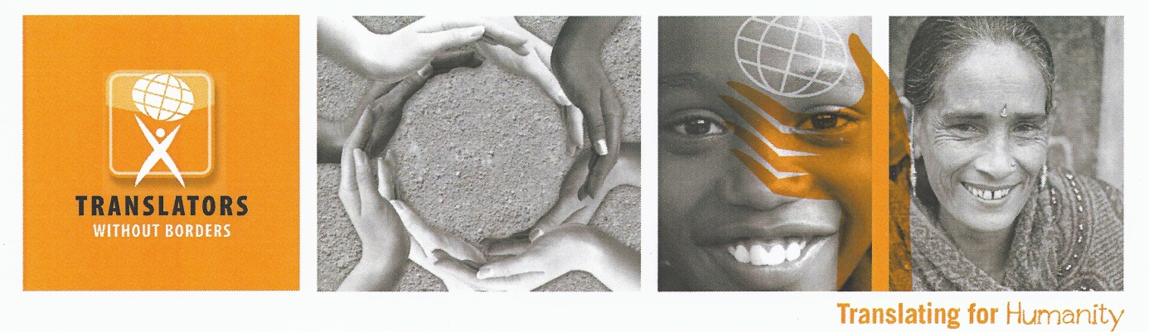
Words of Relief Interpreters

Location: Flexible with travel to Greece

Translators without Borders, a US 501(c) 3 non-profit with an operations center in Kenya, was founded in 1993 to provide volunteer translations to non-profit organizations. In 2010, the organization started a virtual platform to better coordinate these resources. In the last five years, we have translated almost 30 million words of life-saving and life-changing content in over 100 languages. Our latest activations around the Ebola crisis and Nepal earthquake have won widespread praise from the international community.
TWB has been operating its Words of Relief program for refugees in Greece since September 2015. We are now expanding to provide on-the-ground interpreting to meet urgent humanitarian needs in the accommodation sites and other places. Experienced interpreters able to work in the most commonly used languages and meeting the other essential criteria listed below, are invited to apply for a place on the first ever humanitarian interpreter roster, to be managed by TWB. The main need at this time is for the following language pairs – English and one or more of the following - Arabic, Farsi, Kurdish (Sorani and Kurmanji), Pashto, Urdu
PLEASE DO NOT RESPOND TO THIS CALL UNLESS YOU CAN OFFER ONE OR MORE OF THESE LANGUAGE PAIRS
The Role
We are seeking skilled interpreters who already have the right to work in the EU, who can deploy to Greece or other countries where needs arise, and provide interpreting services on the ground, in crowded refugee accommodation sites, urban short-stay accommodation (e.g. hostels), ad hoc camps (e.g. on borders), medical facilities, transport hubs, other places as needs arise.
Responsibilities
- daily ad hoc face-to-face interpreting
- interpretation of focus group discussions, surveys, interviews, audio recordings
- assisting aid workers with language communications regarding distribution of food and non-food items
- assessing information needs of refugees and those working with them
- being available for other individual or group interpreting needs as they arise
The work will be variable and changeable. Roster members will need to be able to work flexibly, to cope with a variety of pressures and to move from one location to another as needs arise.
We will be providing protection-focused humanitarian training for selected TWB roster members, to develop a team that is particularly sensitive to the communications challenges when working with vulnerable groups.
Qualifications
Translators Without Borders is seeking both professional and nonprofessional interpreters who meet the following criteria:
Professional interpreters with a minimum of 4 years of professional interpretation experience or 2 years of professional interpretation experience and a university degree in interpretation or related subject. Relevant professional certification and current membership of a relevant professional body
Interpreters who have with advanced English language skills specific to community interpreting situations, some experience in interpreting in a public sector context, and proven skills in consecutive interpreting. Interpreters must also be familiar with the role of the community interpreter and the contexts in which they work.
In addition, all candidates must meet the essential personal criteria listed below:
- High level competency in one or more of these language pairs - English and one or more of the following - Arabic, Farsi, Kurdish (Sorani and Kurmanji), Pashto, Urdu
- EU passport holder, or for non-EU candidates, a valid EU work permit
- Good speaker, with clear enunciation and pronunciation and good memory retention skills
- Strong cultural sensitivity
- Familiarity with word processing and spreadsheet software
- Flexible, able to work independently and in teams. Resilient, calm under pressure
- A commitment to Translation without Borders core values as listed below
Desired / additional criteria
- An understanding of the context of the European refugee/Migrant crisis
- Experience of working with migrants, refugees or members of minority communities
- Experience of working with children and vulnerable adults
- Facilitation skills working with groups
- Driving license
Women are particularly encouraged to apply.
Recruitment process

Due to urgent needs on the ground, we are inviting immediate applications and we will be contacting suitably qualified applicants as and when deployment needs arise. We will aim to notify you within 30 days to let you know whether or not you are being considered for inclusion on the roster.
This is a rolling recruitment process and will remain open until 30 June 2016. Further calls will be issued in future as needs arise.
Translators already on the TWB database are welcome to apply to join the roster if they meet the criteria. We are also happy to hear from others who have not worked with TWB before.
Complete this form to apply
Core Values
Translators without Borders employees and volunteers are made of people who believe passionately about the value of this work and take personal responsibility for achieving the mission. Translators without Borders’ mission and organizational spirit embody the core values established in its strategic framework:
Excellence: As the leading voice for communicating humanitarian information in the right language, Translators without Borders is a leader in the translation industry and in the non-profit sector.
Integrity: Translators without Borders believes that every person, whether it’s the people who we serve, our volunteers or our staff, has value, deserves respect and has inherent dignity.
Empowerment: Translators without Borders believes in using language to empower people around the world to control their own development and destiny.
Innovation: Translators without Borders recognizes and celebrates the power of innovation to address humanitarian and crisis issues around the world.
Sustainability: Translators without Borders recognizes that meeting our mission necessitates establishment and maintenance of a solid financial and organizational infrastructure.
Tolerance: Our staff and volunteers are highly knowledgeable and skilled; value each other, our partner and our recipients; create a supportive work environment; and, conduct themselves professionally at all times.

Organizational Background
Translators without Borders envisions a world where knowledge knows no language barriers. The US-based nonprofit provides people access to vital knowledge in their language by connecting nonprofit organizations with a professional community of volunteer translators, building local language translation capacity, and raising awareness of language barriers. Originally founded in 1993 in France as Traducteurs sans Frontières (now its sister organization), Translators without Borders translates millions of words per year, provides rapid response teams for crises and trains community and professional translators in places where translation is not well established. For more information and to volunteer or donate, please visit: http://www.translatorswithoutborders.org or follow on Twitter at http://www.twitter.com/TranslatorsWB.

