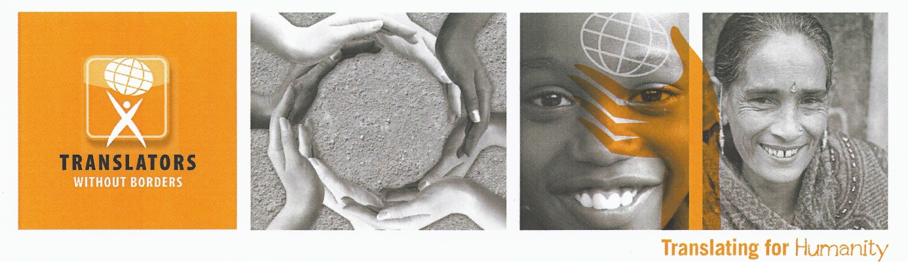
Terms of Reference
Monitoring and Evaluation Coordinator
European Refugee Response
May – July, 2016

About Translators without Borders
Translators without Borders, a US 501(c) 3 non-profit with a translator training center in Kenya, was founded in 1993 to provide translations to non-profit organizations. In 2010, the organization started a virtual platform to better coordinate these resources. Our vision is a world in which information knows no barriers. We do this by providing life-saving information in languages and formats that people can access. In the last five years, we have translated over 30 million words of life-saving and life-changing content in over 150 languages. Our latest activations for the European Refugees, the Ebola crisis and Nepal earthquake have won widespread praise from the international community.

Background
Since December, 2016, Translators without Borders has been working in coordination with a network of organizations in Greece, responding to the needs of those fleeing from violence and hardship in the Middle East and beyond. Our Words of Relief package provides rapid translation in Farsi, Arabic and Greek to ensure that those arriving in Greece have authoritative information in order to make decisions about what they will do next. We are also in the process of developing the first roster for humanitarian interpreters, whom we aim to start deploying within the project period. Translators without Borders is committed to providing high quality monitoring and evaluation of our projects to ensure that ongoing and new activities are relevant, sustainable and effective.
Responsibilities
Reporting to the Project Director, the consultant will:
- Work with the program team to design the MEL plan for the project.
- Work with the MEL consortium lead (ACF) to ensure our MEL plan is in line with the consortium MEL plan.
- Work with the communications manager to hire enumerators to collect relevant data.
- Design data collection tools.
- Train the enumerators on data collection.
- Write a final MEL report with concrete actions for project improvement.

These roles and responsibilities are approximate and may change over time.

Key Deliverables:
- By 27 May, finalise MEL plan in coordination with the Start network
- By 10 June, recruit and train enumerators for data collection.
- Until 30 June, oversee data collection and analysis. Work closely and train Communications Manager for future data collection.
- 10 July, deliver draft final MEL report, challenges/issues, lessons learned and recommendations.

Required skills
- Background in MEL in humanitarian context
- Experience in training enumerators on data collection and analysis
- Excellent data analysis skills (quantitative and qualitative)
- Self-starter; able to work independently
- At least 4 years of experience in international humanitarian or development field
- Excellent communications skills
- High degree of accuracy and attention to detail
- Comfort with working remotely using Skype, email, and other forms of electronic communications.

Most importantly the chosen candidate will have an interest in helping us meet our mission to bring freely available live-saving information to all people in appropriate ways.

Translators without Borders does not have a physical office. All our staff are based from home. This position will require some travel to Greece, most likely between 8 – 17th June.

Apply with a CV and Cover letter to jobshelp@translatorswithoutborders.org

Timeframe: This position will start immediately. It is expected that this will be a part time position with a maximum of 20 days work between 10 May and 10 July 2016. It is planned that the breakdown of days will be as follows, but this is liable to change in consultation with the consultant.
- Design MEL plan in coordination with TWB project team and Start network (4 days)
- Recruit and train enumerators (6 days)
- Design data collection tools and oversee data collection and analysis (6 days)
- Draft final report, collate feedback and circulate final report (5 days)

Core Values
Translators without Borders employees and volunteers are made of people who believe passionately about the value of this work and take personal responsibility for achieving the mission. Translators without Borders’ mission and organizational spirit embody the core values established in its strategic framework:
Excellence: As the leading voice for communicating humanitarian information in the right language, Translators without Borders is a leader in the translation industry and in the non-profit sector.
Integrity: Translators without Borders believes that every person, whether it’s the people who we serve, our volunteers or our staff, has value, deserves respect and has inherent dignity.
Empowerment: Translators without Borders believes in using language to empower people around the world to control their own development and destiny.
Innovation: Translators without Borders recognizes and celebrates the power of innovation to address humanitarian and crisis issues around the world.
Sustainability: Translators without Borders recognizes that meeting our mission necessitates establishment and maintenance of a solid financial and organizational infrastructure.
Tolerance: Our staff and volunteers are highly knowledgeable and skilled; value each other, our partner and our recipients; create a supportive work environment; and, conduct themselves professionally at all times.

