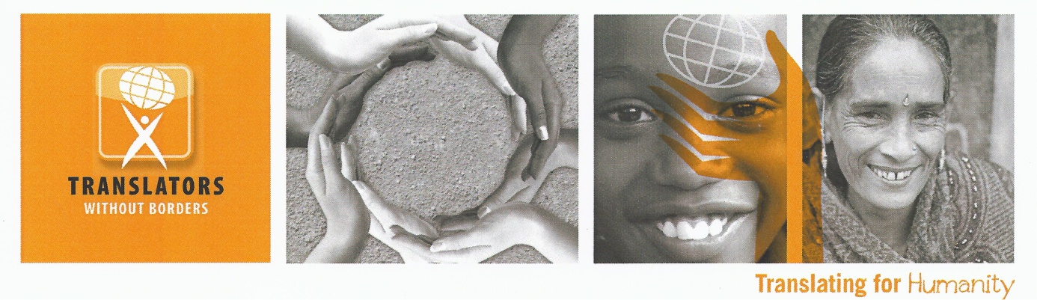

Project Manager - West Africa Health and Capacity Building

The mission of Translators without Borders is to provide people access to vital knowledge in their language through translation, training of translators, best use of technology, and building translation capacity in underserved languages.

Contract length: 7 months (June – January)

Hours: Full time

Location: Flexible; must be able to establish a home office

Travel: Possible travel to Guinea

The Role

The West Africa Health and Capacity Building Project Manager will work closely with the Deputy Director to execute our health translation and training project for Guinea.

Responsibilities

* Oversee TWB’s partnership with eHealth Africa Guinea to execute on health translation and training grant for Guinea.
* Establish weekly check-ins with project lead at eHealth.
* Build and execute work plan for project.
* Ensure compliance with donor requirements and regulations.
* Manage and oversee expenditure and carefully monitor budget (expenditure vs actual)
* Ensure that the management and donors are aware of extensions, budget revisions or substantial changes in the project. Liaise with funders and report issues to deputy director and executive director.
* Proactively seek opportunities for the furthering of the project and for TWB projects elsewhere, especially in West Africa.
* Monitor and supervise work of project team, including volunteers and new trainees.
* Manage project budget and provide necessary documentation to finance director and accountant.
* Work closely with Head of Technology to ensure use of computer-assisted translation tools and enhance incentive program for volunteers.
* Oversee recruitment of trainees and work with Head of Training to develop training program.
* Manage monitoring, evaluation and learning (MEL) for the project, including specific monitoring tools for language-specific communities.
* Maintain open and professional relationships with the internal TWB team, TWB volunteers and our partners.
* Ensure dissemination of proactive, open content for affected populations through a variety of channels.
* Follow up to ensure agency specific content is disseminated.
* Work with team on monitoring and evaluation, including specific monitoring tools for language-specific communities.
* Ensure timely and accurate reporting to feed into overall project reports.

**Qualifications**

The Project Manager should be enthusiastic about the importance of increasing access to knowledge through language. The right candidate is an energetic team player and leader who agrees with TWB´s basic beliefs and values and who can work virtually with team members based throughout the world.

* Able to innovate to find creative solutions; willing to explore new technologies
* Resourceful, able to get more out of small budgets
* Experienced project manager
* Experience managing volunteers
* Previous experience with non-profit organizations, particularly in development is a plus
* Previous experience in training is a plus
* Strong writing skills

Requirements

* Advanced degree in social sciences or related and relevant field, preferably at the Masters level
* 3 – 5 years of project management experience, preferably including remote management
* Language or translation experience required
* Fluency in English; strong proficiency in French
* Humanitarian/Development experience preferred
* Background in training and/or capacity development
* Demonstrated writing experience
* Demonstrated experience with translation tools
* Track record working with volunteers and small teams

Core Values

Translators without Borders employees and volunteers are made of people who believe passionately about the value of this work and take personal responsibility for achieving the mission. Translators without Borders’ mission and organizational spirit embody the core values established in its strategic framework:

Excellence: As the leading voice for communicating humanitarian information in the right language, Translators without Borders is a leader in the translation industry and in the non-profit sector.

Integrity: Translators without Borders believes that every person, whether it’s the people who we serve, our volunteers or our staff, has value, deserves respect and has inherent dignity.

Empowerment: Translators without Borders believes in using language to empower people around the world to control their own development and destiny.

Innovation: Translators without Borders recognizes and celebrates the power of innovation to address humanitarian and crisis issues around the world.

Sustainability: Translators without Borders recognizes that meeting our mission necessitates establishment and maintenance of a solid financial and organizational infrastructure.

Tolerance: Our staff and volunteers are highly knowledgeable and skilled; value each other, our partner and our recipients; create a supportive work environment; and, conduct themselves professionally at all times.

**To apply, please provide a CV and cover letter to** [**jobshelp@translatorswithoutborders.org**](mailto:jobshelp@translatorswithoutborders.org)**.**

**specifying the vacancy title in the subject line. Closing date is 22 June 2016.**

Organizational Background

Translators without Borders envisions a world where knowledge knows no language barriers. The US-based nonprofit provides people access to vital knowledge in their language by connecting nonprofit organizations with a professional community of translators, building local language translation capacity, and raising awareness of language barriers. Originally founded in 1993 in France as Traducteurs sans Frontières (now its sister organization), Translators without Borders translates millions of words per year, provides rapid response teams for crises and trains community and professional translators in places where translation is not well established. For more information and to volunteer or donate, please visit: <http://www.translatorswithoutborders.org> or follow on Twitter at <http://www.twitter.com/TranslatorsWB>.