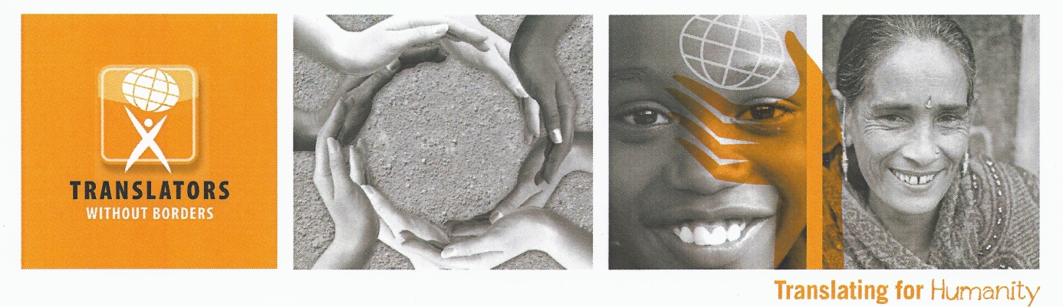
Humanitarian Interpreter Roster Officer (HR)

Contract length: 2 months part time with possibility of extension
Location: Flexible

Translators without Borders, a US 501(c) 3 non-profit with an operations center in Kenya, was founded in 1993 to provide volunteer translations to non-profit organizations. In 2010, the organization started a virtual platform to better coordinate these resources. In the last five years, we have translated almost 30 million words of life-saving and life-changing content in over 100 languages. Our latest activations around the Ebola crisis and Nepal earthquake have won widespread praise from the international community.

Most recently, we have activated our Words of Relief crisis relief network to provide rapid response translation for organizations responding in the European Refugee crisis. In April 2016, we have launched the second phase of the project with funding from DFID and the Start Network. This phase includes the development of a roster of interpreters to work in humanitarian response.

The Role
The Roster Officer will work closely with the Project Manager and Roster Manager on our Words of Relief European Refugee Crisis project phase II. The Roster Officer will contribute to the recruitment, onboarding and de-briefing of applicants to the Words of Relief Humanitarian Interpreter Roster.

Responsibilities

- To monitor our roster tracker, screen incoming applications, establish right to work status, organize language testing, set up interviews, take up references, carry out anti-terrorism checks, organize candidates to obtain criminal record checks. Also, monitor the tracking system for lost / stuck candidates and trouble shoot with colleagues. Monitor the working of the system, suggest improvements, and work on agreed changes with IT team.
- For the roster itself, work with the team to implement and run an effective database, monitor status of all roster members, be first point of contact for members with the roster team, establish regular communication system with roster preparing updates, advisories, etc. in coordination with colleagues. Ensure that all induction programs are completed for each roster member, including arranging training where necessary, support logistics, (flight bookings, transfers, accommodation and reception in country). Arrange health and security briefings, provide any other information needed.
- Filing - keeping the system up to date, ensuring individual data is carefully stored and backed up. Keeping full records of candidate's progress and roster members' deployment etc.
- Maintain open and professional relationships with the internal TWB team, TWB volunteers and our partners.
- Ensure timely and accurate reporting to feed into overall project reports

Qualifications
The Roster Officer should be enthusiastic about the importance of increasing access to knowledge through language. The right candidate is an energetic team player and leader who agrees with TWB´s basic beliefs and values and who can work virtually with team members based throughout the world.

Requirements
- 3+ years of resource experience
- Humanitarian aid experience preferred
- Interpretation/ Translation experience preferred
- Experience working with a roster preferred
- Familiarity with the translation, language or content industries
- Flexible location

To apply, send your CV and a cover letter to jobshelp@translatorswithoutborders.org, specifying the vacancy title in the subject line. Closing date is 10 June 2016 however due to the urgent nature of this recruitment the candidate may be selected before the deadline.

Core Values
Translators without Borders employees and volunteers are made of people who believe passionately about the value of this work and take personal responsibility for achieving the mission. Translators without Borders’ mission and organizational spirit embody the core values established in its strategic framework:
Excellence: As the leading voice for communicating humanitarian information in the right language, Translators without Borders is a leader in the translation industry and in the non-profit sector.
Integrity: Translators without Borders believes that every person, whether it is the people who we serve, our volunteers or our staff, has value, deserves respect and has inherent dignity.
Empowerment: Translators without Borders believes in using language to empower people around the world to control their own development and destiny.
Innovation: Translators without Borders recognizes and celebrates the power of innovation to address humanitarian and crisis issues around the world.
Sustainability: Translators without Borders recognizes that meeting our mission necessitates establishment and maintenance of a solid financial and organizational infrastructure.
Tolerance: Our staff and volunteers are highly knowledgeable and skilled; value each other, our partner and our recipients; create a supportive work environment; and, conduct themselves professionally at all times.

Organizational Background
Translators without Borders envisions a world where knowledge knows no language barriers. The US-based nonprofit provides people access to vital knowledge in their language by connecting nonprofit organizations with a professional community of volunteer translators, building local language translation capacity, and raising awareness of language barriers. Originally founded in 1993 in France as Traducteurs sans Frontières (now its sister organization), Translators without Borders translates millions of words per year, provides rapid response teams for crises and trains community and professional translators in places where translation is not well established. For more information and to volunteer or donate please visit: http://www.translatorswithoutborders.org or follow on Twitter at http://www.twitter.com/TranslatorsWB.

